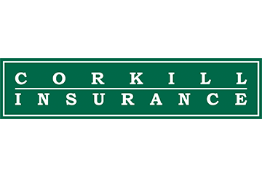
Provided by Corkill Insurance Agency, Inc.
Work-related injuries

An injury or illness is work-related if an event or exposure in the work environment either caused or contributed to the resulting condition or significantly aggravated a pre-existing injury or illness.
Exempt Industries
- Employers in some industries are not required to keep OSHA injury and illness records.
- OSHA, the Bureau of Labor Statistics (BLS) or a state agency can overrule this exemption by notifying exempt establishments that they are required to create and maintain workplace injury and illness records.

Identifying OSHA Recordable Incidents
The Occupational Safety and Health Act (OSH Act) generally requires covered employers to prepare and maintain records of occupational injuries and illnesses. The Occupational Safety and Health Administration (OSHA) is a part of the U.S. Department of Labor and is responsible for administering the recordkeeping system established by the OSH Act.
To comply with OSHA’s recordkeeping rules, employers must first determine which incidents to record. In some cases, this can require a detailed analysis to assess whether an incident is work-related.
This Compliance Overview provides a sample workflow employers can use to determine whether an injury or illness is work-related and must be entered into the organization’s OSHA records. Employers can also reference published OSHA guidance and frequently asked questions in their efforts to determine whether to record a specific incident.
Links And Resources
- OSHA Injury and Illness Recordkeeping and Reporting Requirements website
- OSHA Forms – 300, 300A and 301

OSHA 300 Recordability Flowchart
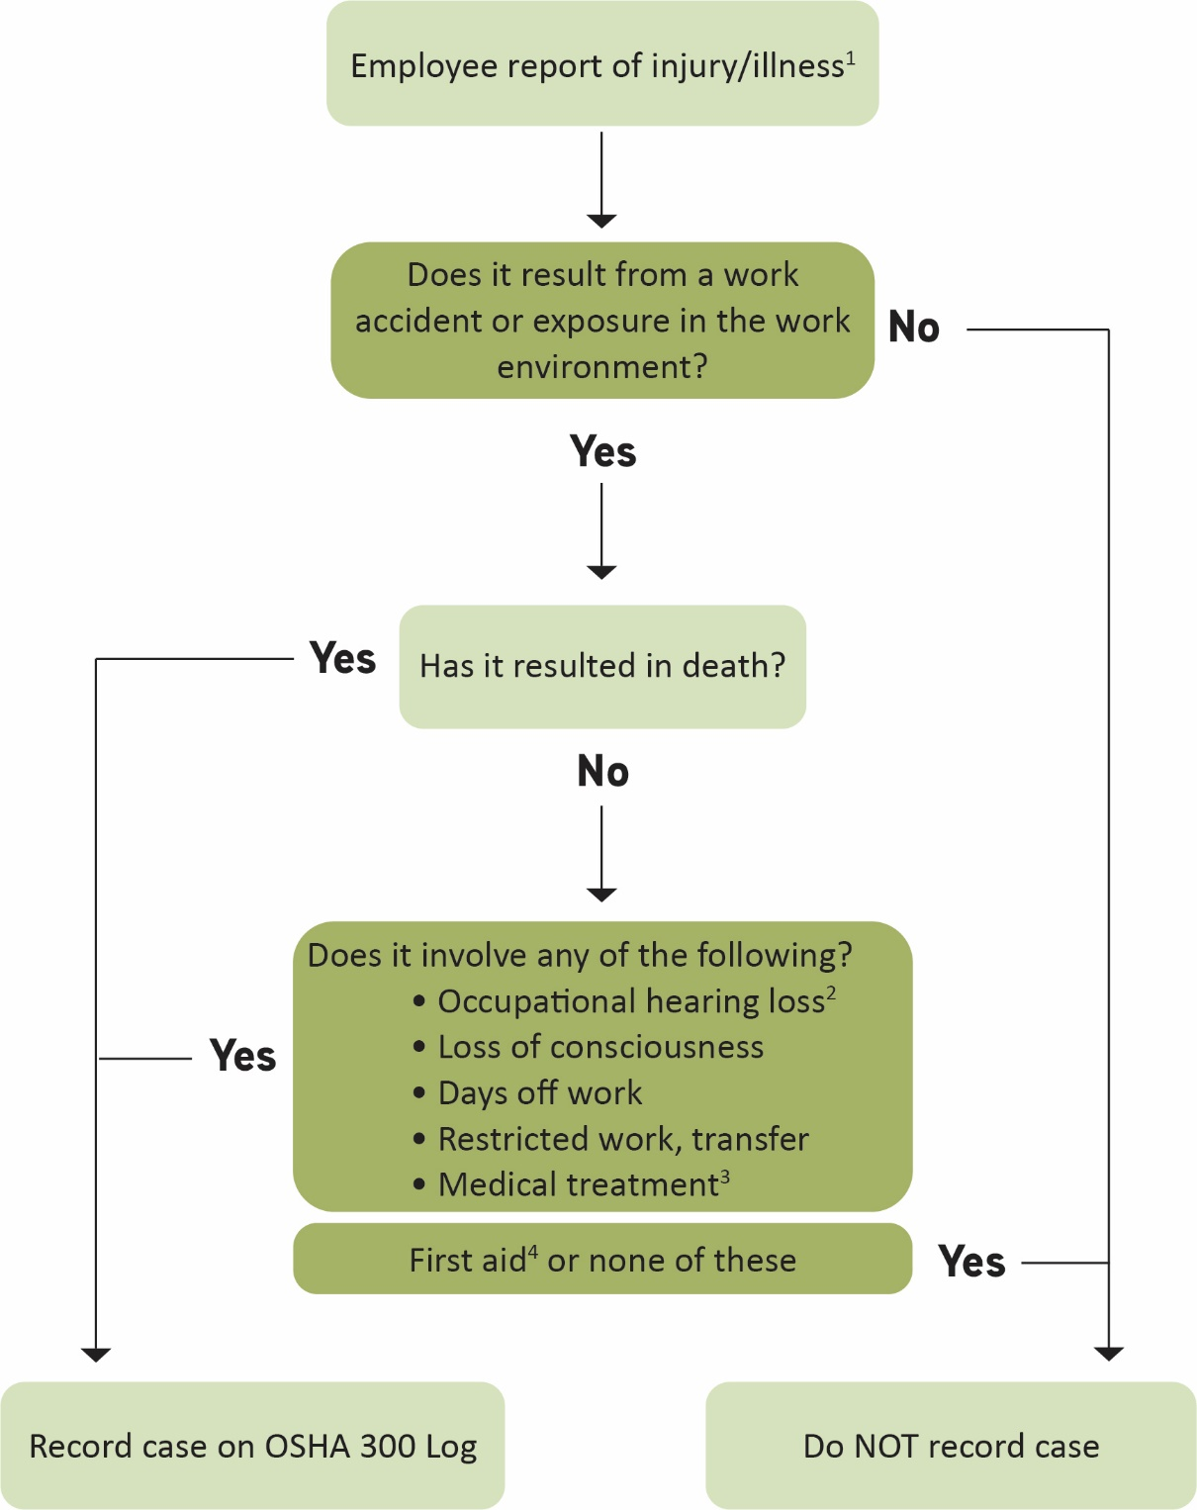

Determining Work-Relatedness
Employers must consider an injury or illness to be work-related if an event or exposure in the work environment either caused or contributed to the resulting condition or significantly aggravated a pre-existing injury or illness. Work-relatedness is presumed for injuries and illnesses resulting from events or exposures occurring in the work environment, unless an exception applies.

Definitions
- Employee Report of Injury/Illness: Injury or illness reported assumes the individual reporting the injury or illness is an employee of . If the employee is a temporary employee from a temporary staffing agency, incidents are to be recorded in the 300 log; however, the temporary staffing agency would be responsible for reporting workers’ compensation claims to the carrier.
- Occupational Hearing Loss: Defined as:
  - A change in hearing threshold relative to the baseline audiogram as an average of 10 decibels (dB) or more in either ear at 2,000, 3,000 and 4,000 hertz.
  - Employee’s total hearing level of 25 dB or more above audiometric zero in both ears at the same hertz levels.
- Medical Treatment: The management and care of a patient to combat disease or disorder. It does not include:
  - Visits to practitioners for observation and/or evaluation only
  - Diagnostic procedures
  - First aid
- First Aid: Defined by OSHA regulations (section 1904.7 (b)(5)). Treatments that are considered first aid include:

  - The use of nonprescription medication at nonprescription strength
  - Tetanus immunizations
  - Cleaning, flushing or soaking surface wounds
  - Use of wound coverings, butterfly bandages, Steri-Strips
  - Use of non-rigid means of support
  - Temporary immobilization devices used to transport victims
  - Drilling of fingernails or toenails or draining fluid from a blister
  - Hot or cold therapy
  - Eye patches
  - Removal of foreign bodies from eye using irrigation or cotton swab
  - Removal of splinters or foreign material from areas other than the eye by irrigation, tweezers, cotton swabs or other simple means
  - Finger guards
  - Massage therapy
  - Drinking fluids for relief of heat stress

Exempt Industries
Employers are not required to keep OSHA injury and illness records for any establishment classified in the following North American Industry Classification System (NAICS) codes, unless they are asked in writing to do so by OSHA, the Bureau of Labor Statistics (BLS) or a state agency operating under the authority of OSHA or the BLS.
All employers, including those partially exempted by reason of company size or industry classification, must report to OSHA any workplace incident that results in a fatality within eight hours. They must also report to OSHA within 24 hours the in-hospitalization of at least one employee, an amputation or the loss of an eye (see § 1904.39). The partially exempt industry classifications are listed in the table below.
NAICS Code | Industry |  | NAICS Code | Industry
4412 | Other Motor Vehicle Dealers |  | 5181 | Internet Service Providers and Web Search Portals
4431 | Electronics and Appliance Stores |  | 5182 | Data Processing, Hosting and Related Services
4461 | Health and Personal Care Stores |  | 5191 | Other Information Services
4471 | Gasoline Stations |  | 5211 | Monetary Authorities - Central Bank
4481 | Clothing Stores |  | 5221 | Depository Credit Intermediation
4482 | Shoe Stores |  | 5222 | Nondepository Credit Intermediation
4483 | Jewelry, Luggage and Leather Goods Stores |  | 5223 | Activities Related to Credit Intermediation
4511 | Sporting Goods, Hobby and Musical Instrument Stores |  | 5231 | Securities and Commodity Contracts Intermediation and Brokerage
4512 | Book, Periodical and Music Stores |  | 5232 | Securities and Commodity Exchanges
4531 | Florists |  | 5239 | Other Financial Investment Activities
4532 | Office Supplies, Stationery and Gift Stores |  | 5241 | Insurance Carriers
4812 | Nonscheduled Air Transportation |  | 5242 | Agencies, Brokerages and Other Insurance- Related Activities
4861 | Pipeline Transportation of Crude Oil |  | 5251 | Insurance and Employee Benefit Funds
4862 | Pipeline Transportation of Natural Gas |  | 5259 | Other Investment Pools and Funds
4869 | Other Pipeline Transportation |  | 5312 | Offices of Real Estate Agents and Brokers
4879 | Scenic and Sightseeing Transportation, Other |  | 5331 | Lessors of Nonfinancial Intangible Assets (except Copyrighted Works)
4885 | Freight Transportation Arrangement |  | 5411 | Legal Services
5111 | Newspaper, Periodical, Book and Directory Publishers |  | 5412 | Accounting, Tax Preparation, Bookkeeping and Payroll Services
5112 | Software Publishers |  | 5413 | Architectural, Engineering and Related Services
5121 | Motion Picture and Video Industries |  | 5414 | Specialized Design Services
5122 | Sound Recording Industries |  | 5415 | Computer Systems Design and Related Services
5151 | Radio and Television Broadcasting |  | 5416 | Management, Scientific and Technical Consulting Services
5172 | Wireless Telecommunications Carriers (except Satellite) |  | 5417 | Scientific Research and Development Services
5173 | Telecommunications Resellers |  | 5418 | Advertising and Related Services
5179 | Other Telecommunications |  | 5511 | Management of Companies and Enterprises
5611 | Office Administrative Services |  | 6244 | Child Day Care Services
5614 | Business Support Services |  | 7114 | Agents and Managers for Artists, Athletes, Entertainers and Other Public Figures
5615 | Travel Arrangement and Reservation Services |  | 7115 | Independent Artists, Writers and Performers
5616 | Investigation and Security Services |  | 7213 | Rooming and Boarding Houses
6111 | Elementary and Secondary Schools |  | 7221 | Full-Service Restaurants
6112 | Junior Colleges |  | 7222 | Limited-Service Eating Places
6113 | Colleges, Universities and Professional Schools |  | 7224 | Drinking Places (Alcoholic Beverages)
6114 | Business Schools and Computer and Management Training |  | 8112 | Electronic and Precision Equipment Repair and Maintenance
6115 | Technical and Trade Schools |  | 8114 | Personal and Household Goods Repair and Maintenance
6116 | Other Schools and Instruction |  | 8121 | Personal Care Services
6117 | Educational Support Services |  | 8122 | Death Care Services
6211 | Offices of Physicians |  | 8131 | Religious Organizations
6212 | Offices of Dentists |  | 8132 | Grantmaking and Giving Services
6213 | Offices of Other Health Practitioners |  | 8133 | Social Advocacy Organizations
6214 | Outpatient Care Centers |  | 8134 | Civic and Social Organizations
6215 | Medical and Diagnostic Laboratories |  | 8139 | Business, Professional, Labor, Political and Similar Organizations

