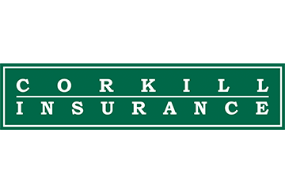
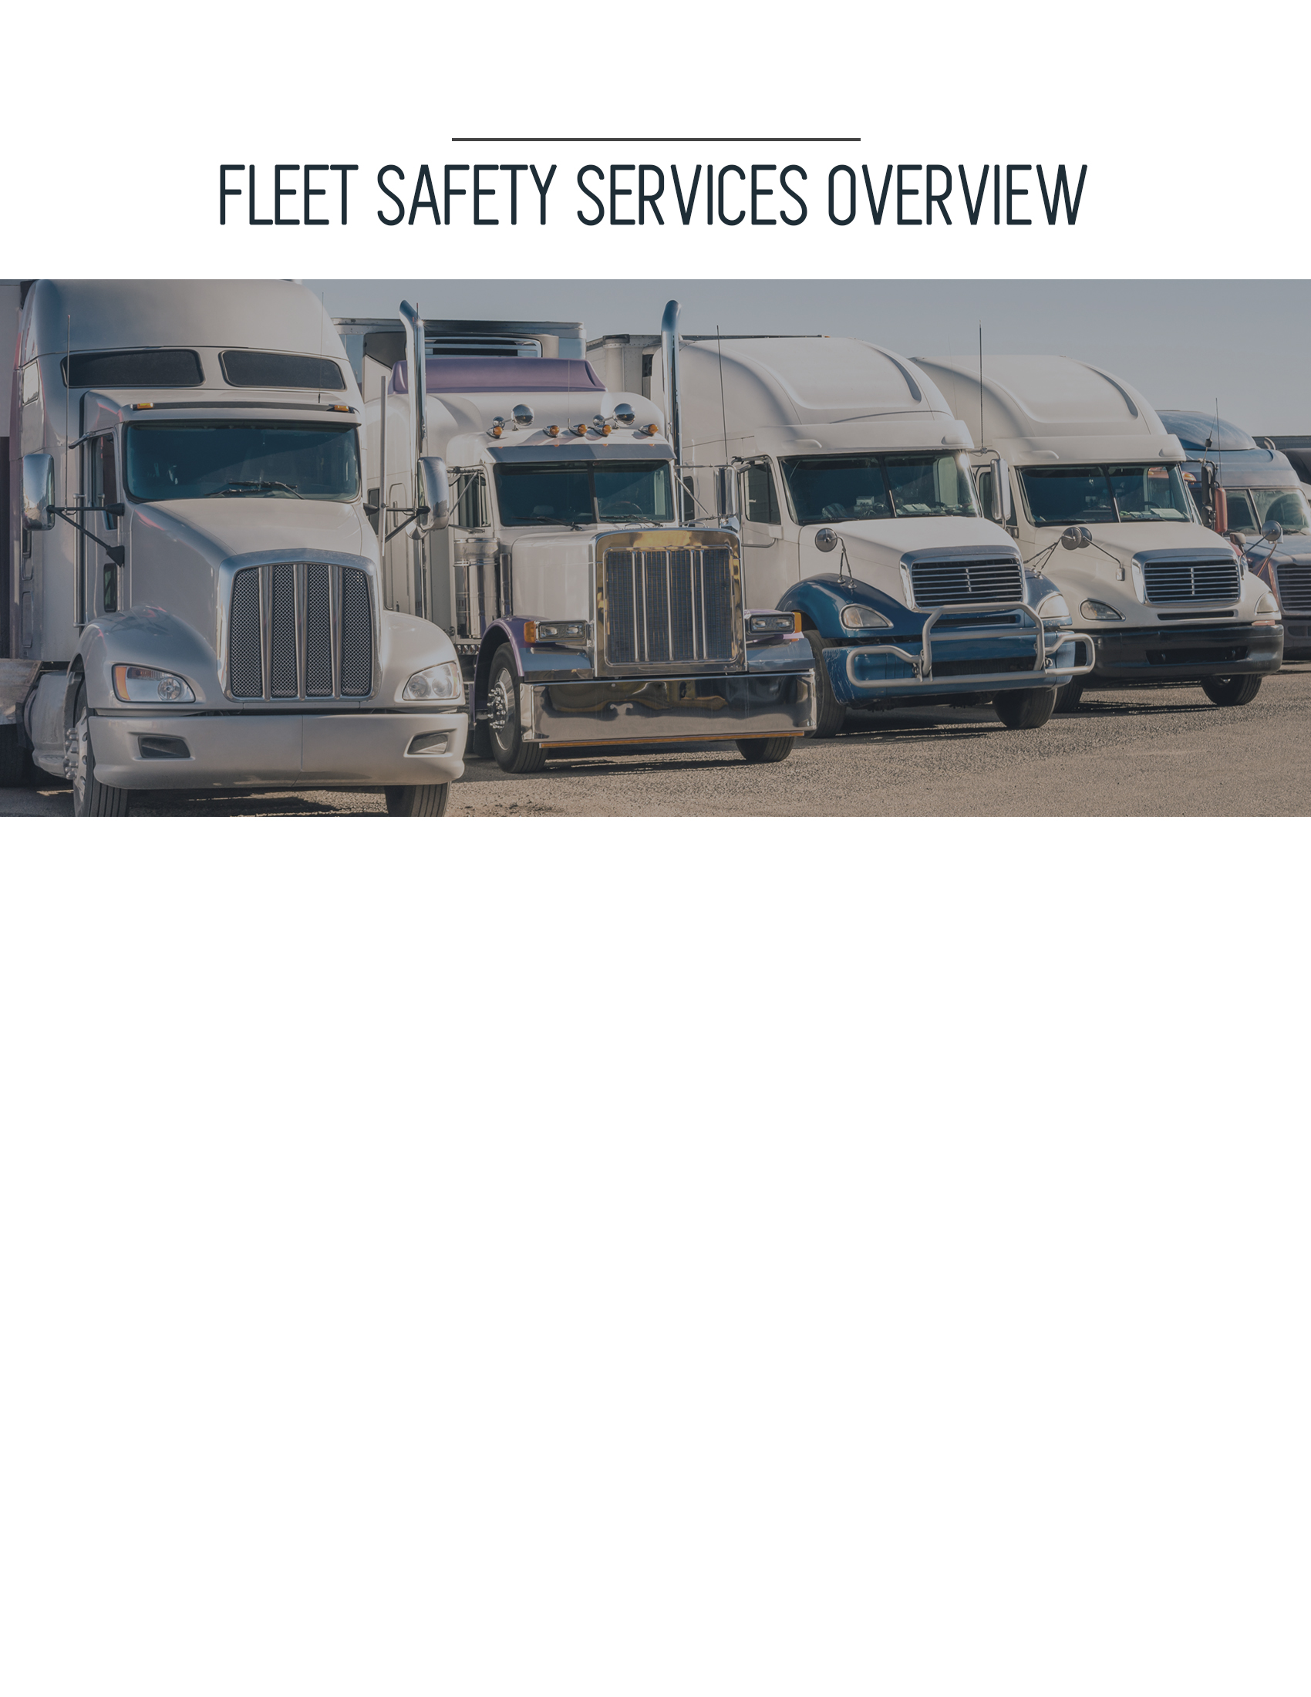
do you have fleet and employee RISK MANAGEMENT programs?
Corkill Insurance Agency, Inc.
- The team of experts at Corkill Insurance Agency, Inc. can help you build a solid loss control and safety program to protect your business. Our transportation industry safety manual and employee safety resources can provide your workplace with risk management information that will help keep your employees safe and committed to your continued success.
are you in compliance with DOT and fmcsa regulations?
- Transportation requires an enormous amount of coordination and recordkeeping. We can offer you bulletins, forms, checklists and guides to help keep you in compliance and cut administrative time even as regulations add to your requirements.
how do you engage employees in your company’s safety culture?
- Our employee safety materials help you promote a safety-minded workplace. We have flyers, posters and toolbox talks on topics such as hazardous material handling, defensive driving and obeying traffic controls.

847-758-1000
http://www.corkillinsurance.com
25 Northwest Point Blvd., Suite 625, Elk Grove Village, IL 60007

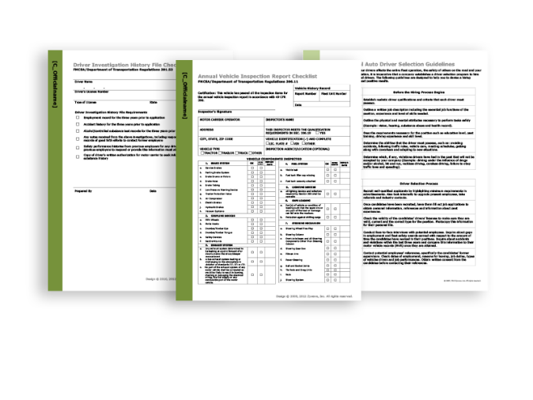
DOT CHECKLISTS
Make sense of Department of Transportation (DOT) regulations using these easy-to-understand checklists. These will also help ensure that you’re always in compliance with complicated recordkeeping regulations.

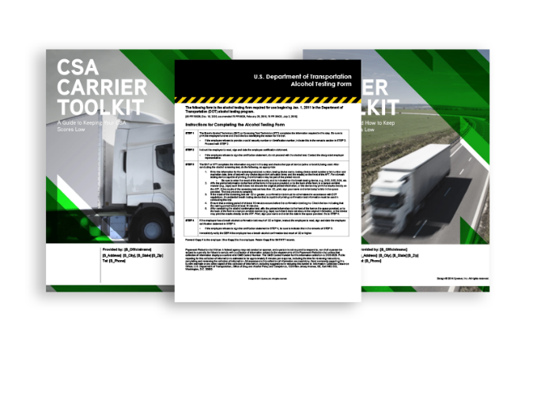
Driver/carrier forms
These forms can help you ensure that your fleet is in compliance with federal and state regulations. You can also use the available toolkits to help you keep your compliance, safety and accountability (CSA) scores low and protect your business’s reputation.

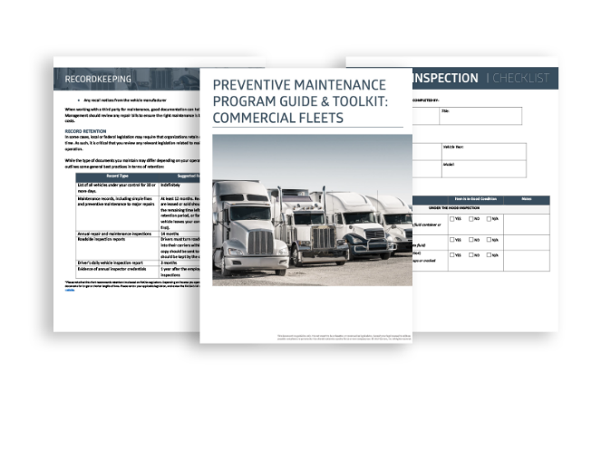
Preventive maintenance program guide
The best way to ensure your fleet’s long-term financial viability is to create a comprehensive preventive maintenance program. Use this guide to create a program that best suits your business and its needs.

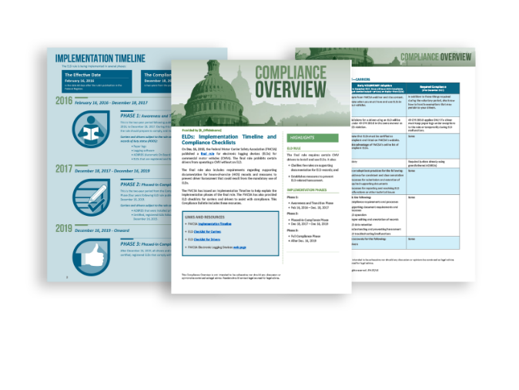
COMPLIANCE BULLETINS
A new federal standard could completely change the way that your fleet operates. Use these attorney-written overviews to understand recent federal legislation and prepare your business for upcoming changes.

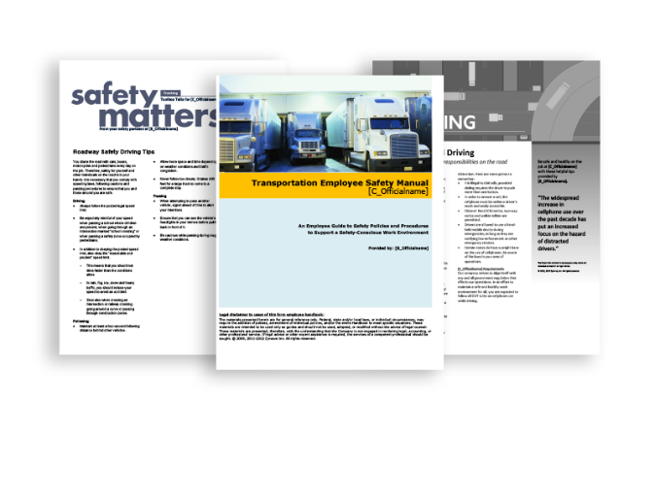
employee safety resources
Keep your employees safe at all times with this library of employee-facing materials unique to the transportation industry. These materials include articles, flyers, newsletters, bulletins and guides that will help keep health and safety top of mind.

