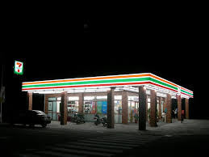
Client 7-Eleven®
No. Units Completed 200 to Date
Size 3,500 SF
Construction Time 90 To 120 Days
Completed 1985-Present
Cost Description $500,000 To $1,350,000
In 1985, John O’Donnell, then Mainstream’s President, began his relationship with Southland Corporation (former corporate name of 7-Eleven®) He began as the Construction Manager overseeing facilities maintenance. Today, Mainstream and its president have built over200 stores throughout the Southeastern U.S. including full-canopy gasoline and convenience centers for what has become the world’s largest operator and licensor of convenience stores. A typical project is constructed on approximately 1-acre, and is composed of a 3,500 SF convenience store and fuel stations. Mainstream oversees construction of the entire site including the installation of underground storage tanks. Projects are completed from 90 to 120 days, depending on size and scope. 