Mountain Consulting Inc. Awards First Annual Scholarship
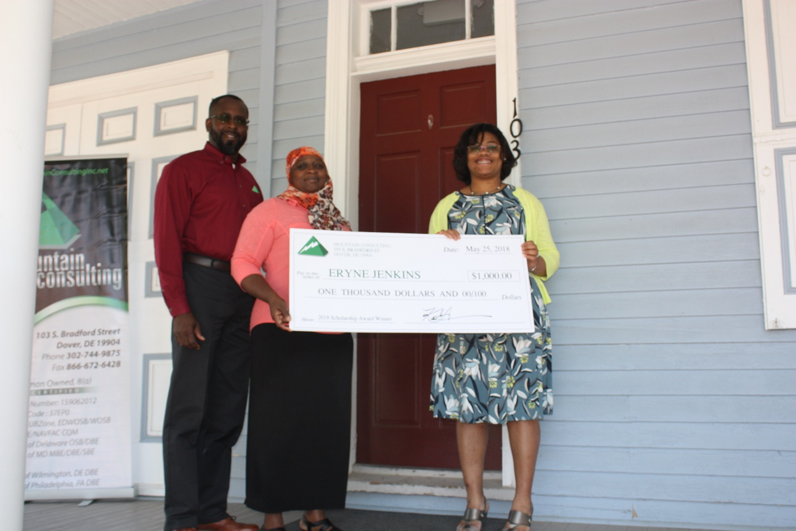

Camden, DE – Mountain Consulting, Inc. has awarded its first $1000 scholarship to Ms. Eryne Jenkins. Eryne Jenkins is a 2018 Graduating senior at Caesar Rodney High School and plans to attend the University of Wisconsin- Madison and pursue a degree in Biochemistry. Her goal is to become a Pediatric Neurologist.
Mountain’s scholarship was open to an underrepresented minority from the State of Delaware who has been accepted into a 4-year accredited college/university with plans to pursue a degree in the fields of Science, Technology, Engineering and Mathematics. This year’s designated minority group was African American. Mountain has plans to have this continue as an annual award.
Mountain Consulting, Inc. is a woman-owned Mountain Consulting, Inc. (MC) is an African American, woman-owned professional services firm founded in 2003. MC provides engineering, construction, land survey, and technical services to both public and private clients, as well as non-profit organizations. We are registered Professional Engineers in Delaware and Maryland and have a network of Professional Land Surveyors licensed throughout the Mid-Atlantic region.

