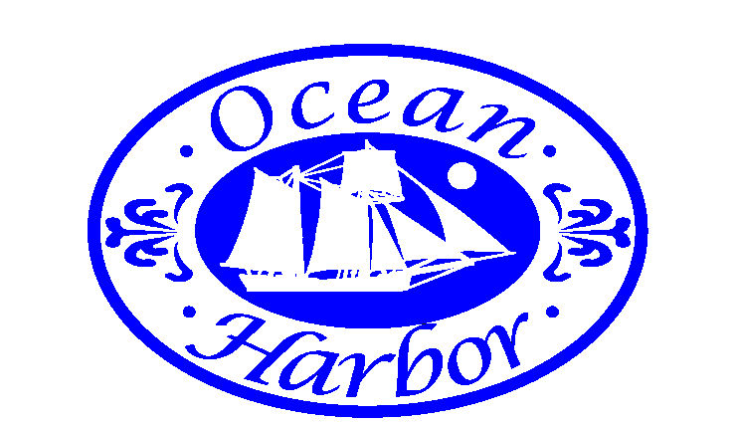
Ocean Harbor Condominium of Fort Myers Beach Association, Inc.
4753 Estero Boulevard, Room 100
Fort Myers Beach, Florida 33931-3923
Telephone Number (239) 463-2385
Fax Number (239) 463-2345

August 18, 2014

To Whom It May Concern:

Elevator works has been a breath of fresh air for Ocean Harbor. We had been with one of the union elevator companies in town for the past decade for our elevator service and felt like we were getting overcharged for what they called "full service".

Elevator Works has given Ocean Harbor more service on an oil and grease contract than we have ever gotten in the past decade. Their prices are fair and their work is excellent. These guys take pride in their work. The team is also great to work with, customer service is always on their mind. If I have a question I feel that Joe and John make sure I understand the answer. I also like that both of the owners were and still are elevator mechanics.

We have just had Elevator Works change out all of our elevator lobby doors, including the door hardware and the whole experience was excellent. The communication, workmanship, process, and product are great. This summer has been a full of projects for Ocean Harbor and Elevator Works has been a contractor I did not have to "babysit". Given my experience with elevator companies in south west Florida I have to say I already searched for better after being unhappy with other companies. With Elevator Works I now have no reason to look for another elevator company.

Best Regards,

James W Murphy

239-233-4366

