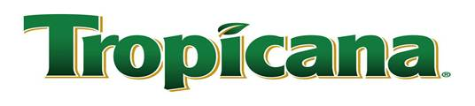

LETTER OF RECOMMENDATION

To whom it may concern:
Please be advised that Gafco Construction, Inc. has successfully worked and completed many interior and exterior industrial painting projects at the Tropicana Plant located in the City of Fort Pierce, Florida. Gafco has worked diligently and satisfactorily to complete all assigned projects on a timely basis and workmanlike manor. They have always been very sensitive to our needs and we won’t hesitate to recommend them.

Sincerely,
Dan R. Gerren
Senior Resource Coordinator
Tropicana - Ft. Pierce
772-489-3367-Phone

