July 28, 2014
As an active board member for Walnut Place HOA in Fremont, CA, I am pleased to provide this letter of reference for AWT Construction Group Inc. I have thoroughly enjoyed the positive working relationship throughout the past 5 years working with James Kint and Greg Smith at AWT Construction Group Inc. I have found that in all cases the work performed by AWT has met or exceeded my expectations on all projects that have been completed.
AWT Construction Group Inc. has been chosen over other companies due to providing fast reliable service at a competitive price. They have consistently taken necessary measures to deliver their work on time and to our Board member’s satisfaction. AWT has always completed within a scheduled time frame and with excellent attention to detail.
I have been extremely satisfied with the work that AWT Construction Group Inc. has completed. It is my pleasure to highly recommend AWT Construction Group Inc. and also look forward to working with them on any future projects.

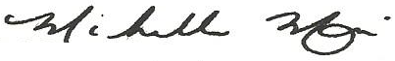
Michelle Marroquin
Board Member
Walnut Place HOA
Fremont CA.

