McFarland business wins 2018 Outstanding Business Governor's Award
By: Jamie Perez – WISC-TV 3, Channel3000.com
Posted: Dec 14, 2018 04:37 PM CST
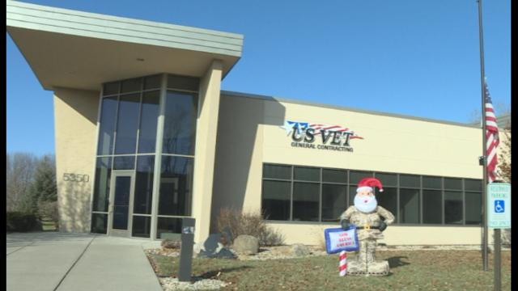
MCFARLAND, Wis. - Nine businesses in Wisconsin received top honors at the 2018 Marketplace Governor's Awards competition, which recognize businesses owned by minorities, women and veterans with service disabilities.
One of the nine businesses that received the award was U.S. Vet General Contracting, LLC in McFarland. With veterans making up about 40 percent of the staff, the president of the business, Matthew Bell, said he chose this line of work to find purpose after leaving the Army.
"In 2009, I retired from the U.S. Army after 20 years and I had a big hole in my life," Bell said. Starting the business in 2010 helped him continue his passion for serving others. He calls it a particularly fulfilling career because he gets to serve other veterans.
Bell said receiving the award is a testament to the hard work his staff puts in on a daily basis.
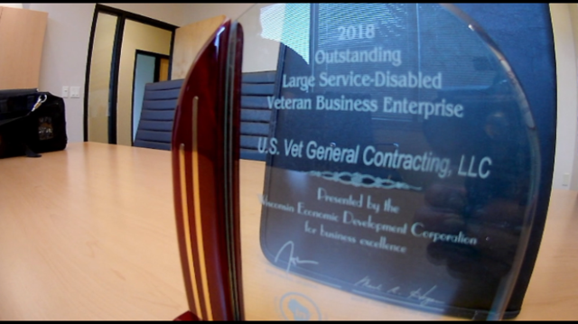
"I owe it all to the employees," he said. "Good employees. They work hard here and they make U.S. Vet look great."
Bell's staffers said receiving the award is an honor and a testament to the hard work Bell puts in.
"He's a great person to work for and really cares about his employees," said Jason Fischl, a project manager at U.S. Vet General Contracting. "He takes care of us very well. We are all proud of him for all the hard work he puts in."
"He's the leader of the pack," said Sarah Berry, Bell's executive assistant. "Matt is a great employer. He is a great boss. He's part of a team. He doesn't put himself above anyone. He's a good person to be around and be with and work for."

