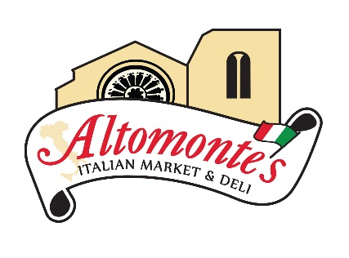
1/23/2017
Mr. Robert Dunn
Lynmar Builders
261 Harvard Avenue
Westville, NJ 08093
Dear Bob,
As we look toward the 1 year anniversary of the opening of our newest and most beautiful store we wanted to take a moment to say thank you. This project was a huge undertaking for us. We thank God we chose Lynmar as our builders. As you know, you were certainly not the cheapest but after this journey there is no one else we would ever build with. From our first meeting, you and your team were forthcoming, thorough, honest and professional. We have seen a ton of contractors & subs come and go in our 45 years in business, many did us no favors, many were flat out detrimental to our operations. But, with Lynmar, we finally found a team dedicated, committed and fighting for us in OUR corner.
We’ve learned to watch what people DO, not what they say they are going to do. From the top to the bottom, everyone at Lynmar was dedicated, efficient, useful and beyond hard working. Ed Barbazon, our Project Manager was a consummate professional, beyond knowledgeable in every facet of the project, continually available, on top of the job, forward-thinking and always two steps ahead. He truly did everything in his power to move mountains for us. He kept the project on task, always communicated with us: good, bad or ugly. But beyond all that he sees things through and his word is golden.
Jason Capehart, our Site Supervisor. Let’s just say mamma is a tough-cookie who doesn’t give the keys of her precious self-made business easily to anyone and yet Jason won her over- because his skills, work-ethic and commitment to the job was obvious in everything he did. If it needed to be done, he got it done. Period. He was present: physically, mentally, morally and truly always with a smile. Jason constantly went above and beyond to not only make sure things were correct but that we were happy. His attention to detail is impeccable and his communication skills, excellent. He always kept us informed of what was going on, what we needed to do in the short and long term. No matter how many stressors, twists and turns this project took he handled it professionally, with care and truly as if it was his very own.
We’ve had the opportunity to work with plenty of your other team including Tom Boyd on-site, who again seemed more like one of own family, taking ownership of the project and caring as if it were his own. Tom Waters during planning was so helpful and really took the time to give us options and budget appropriately. Bottom line, these guys care and take pride in their work. It’s also easy to see why you choose to work with the sub-contractors that you do. They mesh well with your company and values because they do quality work in a timely manner.
Finally, Bob, if it wasn’t for your trust, vision and belief in this project, it would have never happened. As picky as we are with contractors, I know you are just as choosey about who you serve. And rightfully so. Thank you for working with our family in every facet of this project. They don’t make ‘em like you anymore and we are beyond lucky to have had your honesty, passion, expertise, care and advice on this project. Even now, that the project is complete, anytime we have needed you or your team, you are right there for us. We continue to be in the ‘best hands’ in the industry with Lynmar. Your maintenance and office team, especially Donna are always just a pleasant phone call away. They truly want to help with anything that may come up.
When you built our newest Altomonte’s Italian Market, you didn’t just build a bricks and mortar building, you built The American Dream. The work ethic and dedication that was carried to this country over 45 years ago, on the backs of two immigrants through blood, sweat and tears was matched by your unwavering commitment to build us a new home in which to continue their legacy. It has been said that, “A fool knows the cost of everything but, the value of nothing.” We have built an invaluable relationship together, it was a pleasure working with all of you and we look forward to the day when we can do so again.
Sincerely
Maria Nappi
Secretary & Creative Director
Altomonte Enterprises Ltd., Bakery & Doylestown Co.
856 North Easton Road
Doylestown, Pennsylvania 18902

