|  |  |
| --- | --- |
| X:\aeline\DBE\OhioUCP.emf |  |
| **www.OhioUCP.org** |

**Certified**

**Small Business Enterprise**

**IV Electric**

13940 Cedar Road, University Heights, Ohio 44118

This certificate acknowledges that the above named firm is certified pursuant to the U.S. Code of Federal Regulations Title 49, Part 26 by the State of Ohio UCP as

a Small Business Enterprise.

(Vendors must be prequalified with ODOT in order to bid on SBE designated projects)

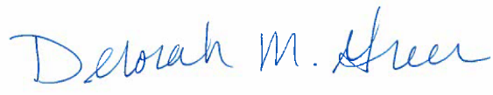

Original Certification Date: 11/16/2015

Deborah M. Green, Administrator

Office of Small and Disadvantaged Business