J.R. Caskey Grading & Excavation
Family Construction Business Overcomes Recession Challenges

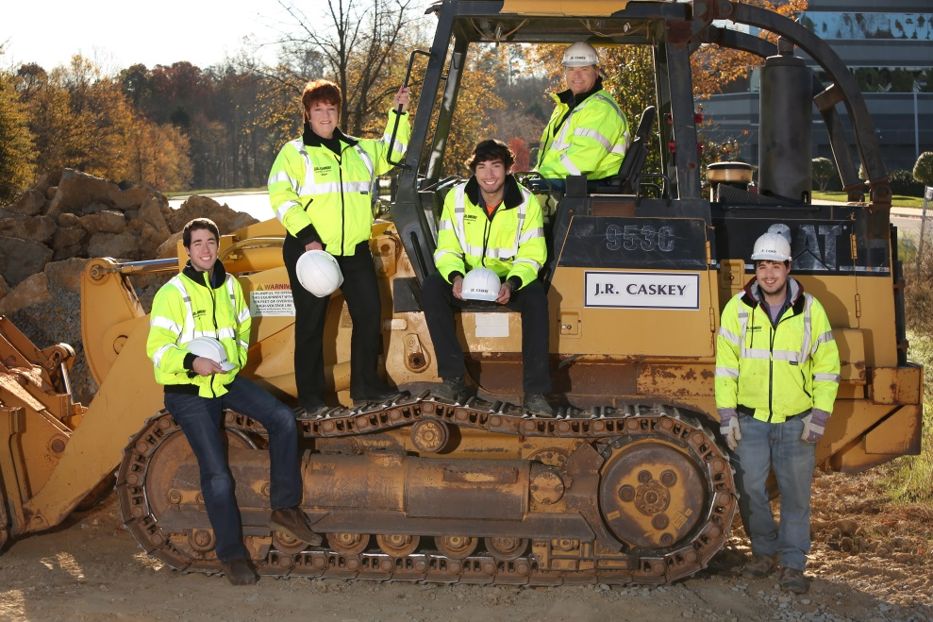

“VCC was sincere and promised to help us, which they have. I would like to commend their efforts on our behalf. It seems our situation has had some unusual complications. VCC did everything possible to keep the ball rolling. VCC and their lending team have been responsive, reliable, and (I guess we rubbed off on them) determined!” Ginger Caskey, President, J.R. Caskey Grading & Excavation

J.R. Caskey Grading & Excavation has been providing complete site preparation services in commercial construction for over 28 years. Recent projects by this family-owned business include the new football field at Randolph-Macon College, a new student dorm at the University of Richmond, the UVA Bookstore expansion, Alderman student housing site and Ruffner Hall renovations at the University of Virginia, and a new parking facility for the University of Mary Washington. Their current client base includes some of the industry’s most reputable general contractors while their target market has become the higher education institutions and facilities as well as a continuing association with Dominion Virginia Power.

Like most construction businesses, J.R. Caskey faced significant challenges in 2008 and throughout the ensuing recession. They were taken by surprise when their long-term business lender decided they no longer wanted to be in the “construction-financing” business and was unwilling to flex according to economic conditions, adopting a hard-line position on all existing loans both personal and company-related. The Caskeys tightened their belts, focused their marketing, and worked hard to keep the business going. VCC stepped in to help with more favorable terms, receptive to their business plan and offered support with a “can-do” attitude. Today, J.R. Caskey has redefined their vision and has risen to a new market above and beyond their pre-recession operations.

VCC participation and funding details:
- New term loan helps company overcome unfavorable fiscal pressures.
- Consolidation and refinancing of existing loans to create more working capital.
- Family business continues on solid standing to create jobs for another three decades.

