City and County of Denver
Comm unity Planning and Development

›v›vw.denvergov.org/conrractor licensing

issued fo:

OJ L EXCAVATING LLC PO BOX 769
FT LUPTON, CO 80621
Licensa/Registration Number: LIC00247692

£xpi/a /ion Oate: 03/31/202 1 License r//›e' D-Water Service

By Authority of tho Executive Director of Community Planninq and Development

Amount Fund/Org/Revenue Code 8250. 00 R35 5600-”-01010-014 1200
Payment Date Trans # 03/$7/2018 4201431
Status Paid

RENEWAL INFORMATION Renewal notices will be e-mailed to e-mail add ress on
Agnew a I information is available at www.denvergov.org/Contractor_Licensing.

INSP EC TION INFORMATION Inspection requests called in by 12:00 a.m. will usually oe
sched u leo for the following working day

Please provide the following information when
call for inspection ”

V Type of inspection and inspection code
Request System: 720-865-2501 Inspectlons are performed Monday through Friday.

Wa llet ?nntraotnr ID Carft - MIUT RF KEPT IN YOUR POS BESSION AT ALL TI MED,

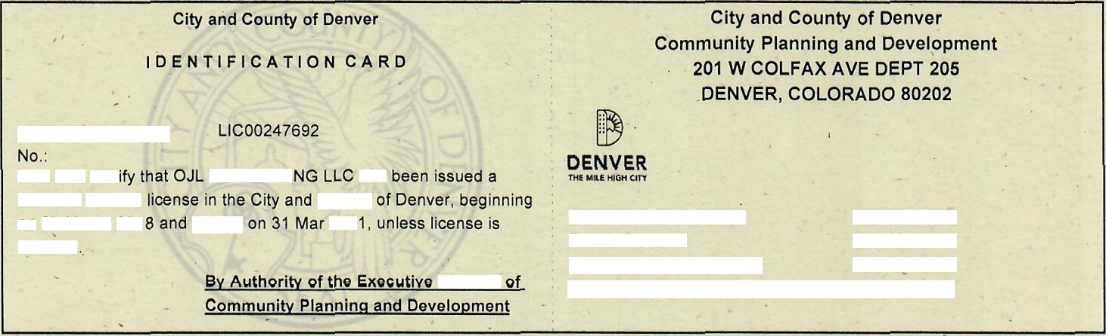C ut on outside of line, then fold in ha If.
License/Registration
D-Water Service
?7 Mnrrh
County
end ino

Licenses & Certificates: | 720.865 2770
Permit Counter: | 720.865 2705
Inspection Administration: | 720.865 2505
Automated lnspection Request: | 720.865.2501

