Delivering Reliable Network Solutions to Achieve
Better Connectivity to the World

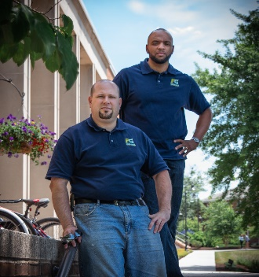
Business Partners Jason Johnson (Jay) and Timothy Penny (Tim) founded Fiber Guyz in 2018 on the philosophy that a client’s fiber optic system should be optimal in both appearance and function. The partners noted that providing phenomenal customer service by exceeding their customer’s expectations is how they want to build their business. Located in Camp Hill, PA, Fiber Guyz prides itself on being a fiber optic company that offers more than professional fiber optic installation services.
“I can’t put into words how lucky Tim and I are to have found Linda.”
-Jay
Owners:
Jay Johnson
& Tim Perry
Fiber Guyz LLC
P.O. Box 253
Camp Hill, PA 17001
(717) 814-9782
(717) 831-8415

info@fiberguyz.net

www.fiberguyz.net

Industry:
Service

Year Founded:
SBDC Assistance:
Marketing Plan
Government Contracting WedNet Grant Program

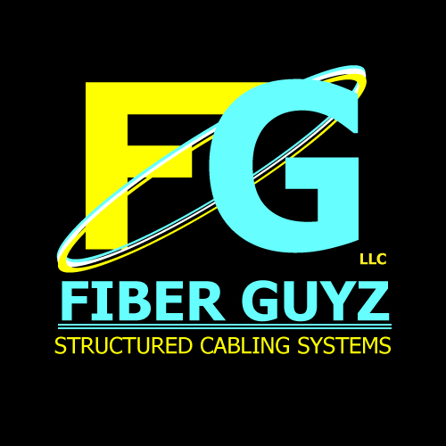
The company holds BICSI certifications, FOA certifications, a CompTIA Security+ certification, electrical licensing, and government clearance. These credentials are on top of 30+ years combined experience. Before starting Fiber Guyz, Jay and Tim understood that maintaining professionalism is paramount to building relationships. As employees working for a large contractor, the partners learned the importance of providing high quality service while installing electrical, fiber optic, data, and paging systems.

After attending a government contracting and bidding information session presented by SBDC Consultant, Linda Grove, at a York County Economic Alliance event in April of 2019, Jay and Tim became interested in becoming a Certified Veteran-Owned business. The co-owners met with Linda to discuss certification and all facets of business operations in May of 2019. The Kutztown University SBDC helped Fiber Guyz develop an outreach and marketing plan to sell their services which immediately brought a new client and contract work to the company. Linda explained the details of applying for veteran-owned certification from the Center for Veterans Enterprise (CVE). While working with Linda, Fiber Guyz learned about the WedNet PA grant program, where they can be reimbursed for advanced technology training needed to run their business. After receiving word from Linda about eligibility for both essential and advanced training reimbursement from the state, Jay commented, “I can’t put into words how lucky Tim and I are to have found Linda”. Tim remarked, “We feel confident in the process because Linda is knowledgeable and passionate about her job. She made us feel like she is part of our business.”

Fiber Guyz provides customers with solutions for all, voice, data, electrical, and paging needs in Carlisle, Chambersburg, Gettysburg, Harrisburg, Mechanicsburg, York, Lancaster, and all the surrounding areas, including northern Maryland.

