Clifton's fourth-generation masters of stained glass
Christopher Maag, Columnist, @Chris_Maag Published 8:58 a.m. ET March 30, 2018 | Updated 9:36 a.m. ET March 30, 2018
The Hiemer & Company Stained Glass Studio has designed stained glass windows since the 1880s, and has operated in Clifton since 1949. The owner, Judith Hiemer Van Wie, talks about the business and how the intricate, colorful windows are made. Kevin R. Wexler/NorthJersey.com
In business since 1931, the Hiemer & Company Stained Glass Studio has created windows for for churches from Alaska to the U.S. Virgin islands.
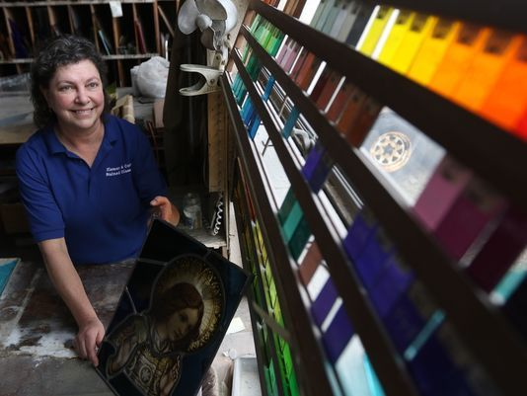
(Photo: Kevin R. Wexler/NorthJersey.com)
When you die, what mark will you leave on this world? How long will your work be seen, your influence felt? We avoid Big Questions like these because, for most of us, the answers linger somewhere in that uncomfortable space between “not much” and “not very.”
Judith Hiemer Van Wie is not like us. Surely she tussles with existential questions of her own. But longevity — the “point” and “purpose” of her life’s work in the long run — is not something she’s ever had to worry about.
Her recent contract at St. Paul Roman Catholic Church in Clifton provides an excellent case in point.
The church, built in 1936, recently found itself in need of an elevator. To make space, Hiemer Van Wie was hired to move and modify two stained-glass windows originally made in Europe in the 12th Century.
Other windows at St. Paul’s were designed by Georg Hiemer, Judith’s great-grandfather, and maintained by Edward and Gerhard Hiemer, her grandfather and father, respectively. These she inspected, and refurbished as necessary.
Hiemer Van Wie also designed a few new windows herself, including one featuring a portrait of Mother Teresa that was installed in 2016. It will adorn St. Paul’s chapel until it, too, needs to be refurbished, in about the year 2150.
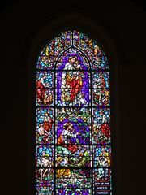
One of dozens of large-scale stained glass windows that Georg Hiemer designed for St. Paul Roman Church in Clifton in the 1930s. (Photo: Kevin R. Wexler/NorthJersey.com)
Here in a single church, the lifespan of Hiemer Van Wie’s work stretches out across a millennium. That’s a kind of longevity most of us will never know.
“I feel awe,” Hiemer Van Wie, 55, said a few days before Easter, “and a sense of pride, too — that my family has created such beautiful things, and that I’ve been able to create things that will last for generations.”
The Hiemer & Company Stained Glass Studio was incorporated in 1931, but its roots stretch back several decades before that. Georg Hiemer grew up on a farm near Munich in the late 1800s. He was lousy at herding geese, but he showed early aptitude as a doodler and painter.
“His father gave him his inheritance early and said, ‘Go be an artist and leave us alone,’” Hiemer Van Wie said.
Today, a person hoping to trade her native artistic talent for a dependable salary might design graphics for tech companies. In the 1880s, Georg Hiemer took up stained glass. Working for some of Europe’s most distinguished companies, he designed windows for churches in Paris and across Germany.
Georg’s son Edward possessed similar talent but was more peripatetic, working in Japan, the Philippines, Mexico City and Columbus, Ohio.
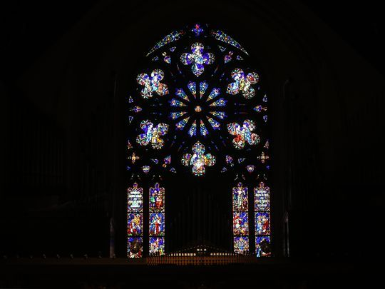
A window designed by Georg Hiemer, and built by his craftsmen, at St. Paul Church in Clifton. (Photo: Kevin R. Wexler/NorthJersey.com)
Georg joined his son in the United States in the late 1920s, and together they founded the family business, which moved to Clifton in 1949. Today the company inhabits a Bauhaus-styled jewelry box, designed by Edward with understated purpose and grace, and big windows facing Crooks Avenue to receive the soft Northern light.
“They used to display an entire window before they sent it out,” said James Van Wie, Judith’s husband, who left his career in business technology 18 years ago to join the glass company. “So instead of holding up one panel at a time to the light, they could look at the whole window.”
Raised on glass
Judith grew up on glass. She started working for the company by cleaning the toilets at age 8. She showed artistic talent early, but her father sent her to business school before letting her take classes at the Parsons School of Design in New York in the late 1980s.
“I was definitely the old-fashioned kid in class,” she said. “I didn’t tell anybody I was a liturgical artist.”
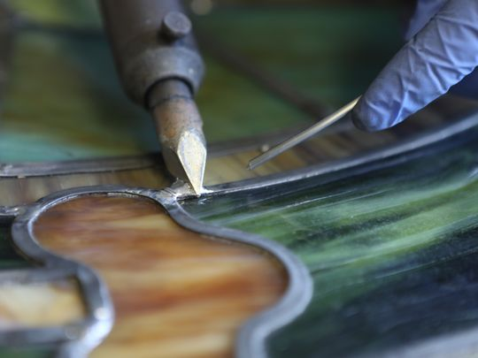
Stained glass may seem impervious to time, but it can shift with gravity or with the movement of century-old church foundations. Panes can fall out or fade after decades of exposure to direct sunlight. “The stained glass, the wooden frames, the building itself,” Hiemer Van Wie said. “Everything expands and contracts, and it all happens at different speeds.” (Photo: Kevin R. Wexler/NorthJersey.com)
For its first 120 years in the glass business, the Hiemer family rode a wave of Catholic expansion, creating stained-glass windows for 1,131 churches. Hiemer glass occupies windows in a Catholic church in St. Croix, in the U.S. Virgin Islands; in a cathedral in Bangalore, India; and in St. Patrick Church in Barrow, Alaska, which claims to be the northernmost Catholic congregation in the world.
For years, the company was responsible for maintaining stained-glass windows set into the front doors of St. Patrick's Cathedral in Manhattan. In 1995, one of the company's windows was blessed by Pope John Paul II during his visit to St. Joseph's Seminary in Yonkers.
One project the company didn't win was Newark's Cathedral Basilica of the Sacred Heart, where construction lasted from 1899 through 1954, nine years before Hiemer Van Wie was born.
She's still a little miffed about it.
"The stained glass was made by an Irish outfit!" she said. "Which was insane when you had six major studios in New Jersey at the time."
Repairs for the ages
Then the trend of Catholic expansion has since flipped. Nearly a third of American adults today were raised Catholic, according to research by the Pew Research Center, but 41 percent of those have left the faith, making Catholicism the fastest-shrinking religion in the Unites States.
“My father got to a point where he didn’t think he was going to make another stained-glass window for the rest of his career,” Hiemer Van Vie said.
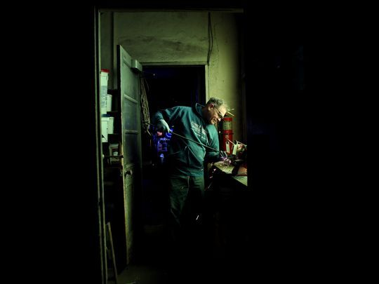
Jeff Longfellow creates a smooth end on a reinforcement bar with a carbide wheel. The bar will later be reattached to refurbished stained glass. (Photo: Kevin R. Wexler/NorthJersey.com)
Stained glass may seem impervious to time, but it has a serious problem with gravity. A saint’s halo, formed in lead and glass at the top of a window, weighs heavily on the feet, which buckle and burble under the load.
Inside the lead skeleton, soldered joints begin to crack. The cement dries and turns to dust. Glass panes split, or fall out entirely.
The decay may be slowed by shade from trees in the churchyard or accelerated by decades of direct sunlight, rotting wooden window frames or a church foundation descending slowly into the uneven ground.
“The stained glass, the wooden frames, the building itself,” Hiemer Van Wie said. “Everything expands and contracts, and it all happens at different speeds.”
Like the glass it produces, a stained-glass company changes size with time. At its height between the 1930s and the 1950s, Hiemer & Company employed 25 people, Van Wie said. Today his eldest daughter, Jessica, 18, helps by sweeping the shop, digitizing the company’s file cabinets of archival paintings, and performing research on liturgical history.
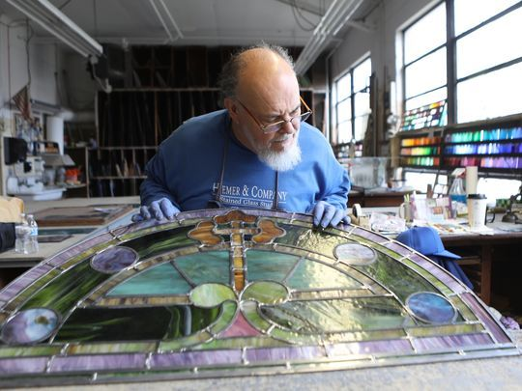
Michael Lomazzo, shop foreman at Hiemer & Company, reviews his work. Lomazzo, 66, has worked for the company for 29 years. (Photo: Kevin R. Wexler/NorthJersey.com)
But Jessica Van Wie shows little interest in becoming the fifth generation of Hiemers to work in glass. (This week she was accepted to the honors program at Rutgers University, where she hopes to study nutrition.)
That leaves Judith Hiemer Van Wie, her husband and six craftspeople. For these few who remain, winning a contract to create a stained-glass window from scratch is something of a treat.
“The restoration work is what keeps us in business,” Van Wie said.
Time creeps ahead
Whether it’s creating her own work or mending windows crafted by her ancestors, Judith Hiemer Van Wie operates in scales of size and time that border on the planetary. Days before Easter, she stood in the nave at St. Paul Church and looked up at a transept window that Georg Heimer designed nearly a century ago. The glass depicts Bernadette, a peasant who achieved sainthood after claiming to have witnessed 16 apparitions of God and the Virgin Mary inside a cave in southern France in 1858.
Photos: Stained glass shines bright in Clifton
Fullscreen
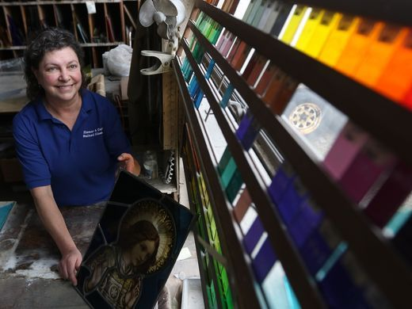
Judith Hiemer Van Wie is the fourth generation owner of Hiemer & Company. Her great-grandfather started designing stained glass windows in Germany in the 1880s before moving to Ohio and then to Clifton. Kevin R. Wexler/NorthJersey.com
Fullscreen

1 of 18

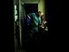

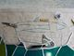

Next Slide
18 Photos
Photos: Stained glass shines bright in Clifton
The window splits the sunlight into gorgeous refractions of red, blue and brown. Also it is huge, with a central panel of Bernadette worshiping at Mary’s feet surrounded by 12 different images from the lives of Bernadette and the church.
From hundreds of feet away, Hiemer Van Wie spotted the dirty footprints of time marching slowly across her great-grandfather’s work. A tiny pane of glass had dislodged Bernadette’s praying hands.
“Can you see it?” she said. “That’s a window we’ll be looking at after Easter.”
Email: maag@northjersey.com

Join and get
1st Month Free
Subscribe Now

CONNECTTWEETLINKEDIN 1 COMMENTEMAILMORE
Share your feedback to help improve our site experience!
From The USA TODAY NETWORK

The troubled star of 'Last Chance U' never found what he neededFor The Win
Undo

The Gronk brothers played flip cup on 'Shark Tank' then walked away with 150kFor The Win
Undo

DeAngelo Williams gets into heated argument with NFL Network hosts over …For The Win
Undo
These sites are part of the USA TODAY NETWORK. Their content is produced independently from our newsrooms.
More Stories
Truck goes into river with father, kids inside
March 30, 2018, 10:11 p.m.

Toys R Us crash leaves large vacancy in Wayne
March 30, 2018, 11:01 p.m.

Hackensack's General Poor's closing - for now
March 31, 2018, 12:59 a.m.
Saddle Brook police rescue man trapped by tree
March 30, 2018, 7:21 p.m.

Mahwah responds to AG's eruv suit
March 30, 2018, 2:34 p.m.
Paramus grad Stacey Dash exits Congress race
March 30, 2018, 6:40 p.m.
by Taboola
Sponsored Links
AD CONTENT

PrebioThrive$49.99 - gundrymd.com

Try Not To Laugh Hysterically At These Bizarre T-ShirtsNinjaJournalist
Undo

Rock and Roll History Owes a Lot to These GirlsParentz Talk
Undo

Clifton, New Jersey: This Unbelievable, Tiny Company Is Disrupting …EverQuote Insurance Quotes
Undo

Schon Zuvitria 37 in. Vanity in Black with Marble Vanity Top in Bl…$799 - homedepot.com

Terrell Owens Had No Idea That $2 Million Bingo Hall Would Ruin …SportsChew
Undo
MORE STORIES

Paterson mom arrested for taking explicit photos of daughter
News,passaic,paterson
| 10 months ago
Undo

Lucky break: Edgewater mother of two wins $5M on ticket bought by mistake
North Jersey
| 3 months ago
Undo

Toys R Us customers denied deals
Business
| 12 days ago
Undo

Clifton couple thought they could adjust their legal status; instead, they were detained
North Jersey
| 22 days ago
Undo

COMMUNITY
THE FABRIC THAT BINDS US
1st Month Free
Subscribe Today

