ABC Warehouse gets monster order for Ford Field, LCA TVs
HASAN DUDAR | DETROIT FREE PRESS | 12:41 pm EST November 9, 2017

Sep 25, 2017; Detroit, MI, USA;
TIM FULLER, USA TODAY SPORTS
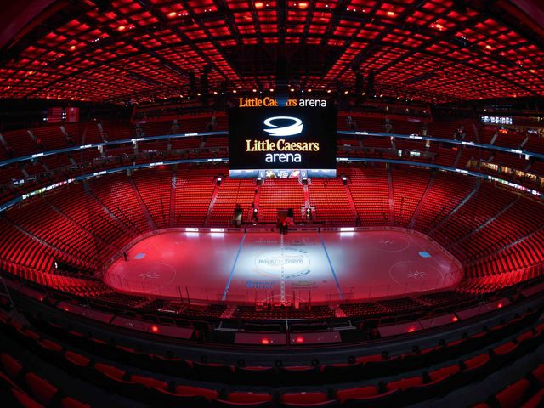

Little Caesars Arena and Ford Field have retained ABC Warehouse to furnish their venues with more than 2,100 television displays, the Pontiac-based electronics and appliance retailer said in a news release.
Dave Kuhnlein, a spokesman for a public relations firm for ABC Warehouse, described it as a "whale of an order."
“This is an example of Michigan businesses working together to keep business in Michigan,” ABC Warehouse CEO Martin Hartunian said in a statement. “They could have selected anyone else, but they partnered with the only family-owned, local multi-store consumer electronics chain in the state."
Ford Field, home of the Detroit Lions, recently added more than 500 screens through ABC Warehouse, including nearly 459 with 4K display resolution, and sizes ranging from 49 inches to 75 inches, according to ABC Warehouse. The displays are designed for “ultimate realism,” the company said in a statement.
Little Caesars Arena, the home of the Detroit Red Wings and Detroit Pistons, opened in September and called for more than 1,600 digital signage and commercial television screens, which ranged in size from 32 inches to 98 inches, ABC Warehouse said. The displays are used in the arena’s restaurants, suites, restrooms, and locker rooms.
“ABC Warehouse is excited to help play a role in Detroit’s resurgence,” Dan Schuh, the company’s executive director of television and a/v Products, said in a statement. “The visuals in these facilities are unsurpassed. The selection of displays, sizes and layouts was choreographed to suit the needs of the facility.”

