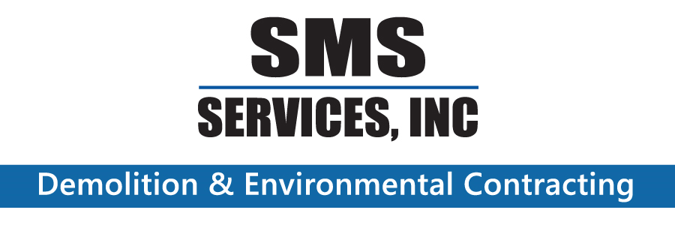
207A East St, Methuen MA
(978) 683-1166

The Blue Book would like to congratulate Future Planet Recycling in their commitment and success in recycling of street lights. Currently FRP has more than a million street lights under contract for dismantlement and recycling of components. Keeping waste items out of the landfill and reusing the materials to make new products, is crucial to the protection of our planet. Future planets recycling is performing a great services and we wish them continued success.

Sincerely,
Shawn M. Slattery

