Caton Communications Group has long been a supporter for the development of young talent. To this end, CCG is a proud member of [IEC's Apprenticeship Program](https://www.ieci.org/apprenticeship). Take a look at how CCG has trained the youth of today into the technicians of tomorrow.

The [IEC Apprenticeship Program](https://www.ieci.org/apprenticeship) allows apprentices to learn while they earn. At CCG, apprentices get to experience innovative and exciting projects as they progress their skills over the course of three years. CCG values bringing the best technology to our customers, so apprentices are able to remain ahead of the industrial curve through practical experience.

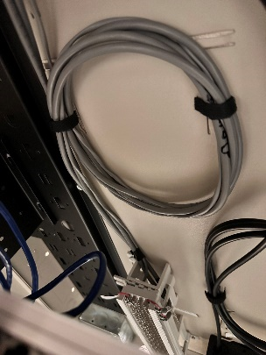

Apprentice Conner Wurm's excellent telecommunications work.

Though CCG implements cutting-edge tools and techniques, we continue to recognize the importance of a strong foundation. We extend our high standard of excellence to apprentices and ensure that they are highly competent in the foundations of telecommunications. This valuable experience allows apprentices to earn over 40 college credits, making earning a college degree all the faster.

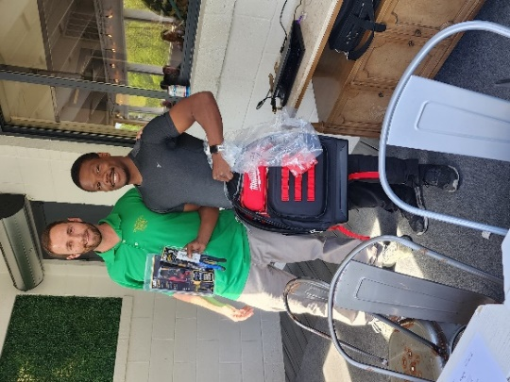

Outstanding employees like Derrick Green receive bonuses at company parties.

Apprenticing at CCG is not merely a day job. Apprentices also get to enjoy the benefits of being a CCG employee, including attending company parties and earning bonuses. CCG recognizes and rewards hard work, meaning your efforts are not unappreciated.

Ed Libertini at Western Tech's Career Fair.

In addition to the IEC Apprenticeship Program, CCG has also been a long-time supporter of the [BCPS Work Based Learning Program](https://westernhs.bcps.org/students/academics/internship_program), attending career fairs at schools like [Western School of Technology](https://westernhs.bcps.org/), [Lansdowne High School](https://lansdownehs.bcps.org/), and [Patapsco High School](https://patapscohs.bcps.org/) and allowing remarkable students to intern at CCG.

So no matter how young you may be, if you have a passion for networking technology, CCG is the place to be! Fill out our [Employment Application](https://ccgusa.net/wp-content/uploads/2016/07/Application-for-Employment_6-17-16.pdf) and submit it to our office to be considered for a position.