Structured Cabling, Networks, Communications, Fiber Optics, Copper, Voice, Data, Video Security, CCTV, Access Control, AV, Sound, Intercom, and more.
In the digital age, computer communication networks & information transport technology have become one of the fundamental necessities to provide fast and reliable ways of managing, securing, and transferring data. Issues regarding networks can come from the initial installation of a network to the expansion of a network. It may be the cause of improper maintenance of a network’s infrastructure. With all these possible issues we want professionals who have the necessary skillsets and knowledge to get these jobs done correctly the 1st time. Caton is one of those companies.
Caton Communications Group, Inc (CCG) is a family own and operated business founded by President Ed Libertini. Ed Libertini has been in the computer and networking industry for over 30+ years. He shares his expertise, and work values with his team of certified, experienced and caring technicians. CCG is a natural extension of Ed, and his teams continued commitment in offering uncompromising “state-of-art” systems. CCG has been part of the technical field for 19 years and counting, growing alongside with technological advancements to provide you with all your needs. If you are curious about their history, read more on their about us page. The motto of Caton has always been “Connecting you to the future!” providing you with the best services in Structured Cabling, Networks, Communications, Fiber Optics, Copper, Voice, Data, Video Security, CCTV, Access Control, AV, Sound, Intercom, and more.
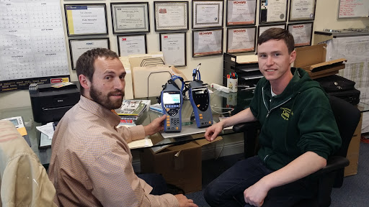
CCG’s technicians have many licenses and certifications under their belts. Some of the more prominent certifications are Certified Fiber Optic Installation Contractor, Mohawk Accredited Contractor, Hubbell Premise Wiring Certified Installer, AMP Netconnect Contractor, Leviton Authorized Network Installer Certification, BICSI (Building Industry Consulting Service) International Member, Optical Cable Corporation Multimedia Design & Integration Specialist, Wiremold Interlink Certified Designer Installer, Hitachi Cable America Open System Architecture Installer Certification and more. If you want to see all their qualifications you can visit their certifications page.
(left) Vice President Ben Libertini and (right) System Integrator Josh Jones posing with Caton’s new Ideal Industry LAN Cable Certification tool.
CCG works with both government and private facilities. Due to security concerns we have for our customers, we will be limiting the details of what we have done for these facilities. CCG worked towards better education, and more futuristic school for students by being apart of Woodlawn high schools’ 2 year renovation project. We worked on the telecom infrastructure upgrade, new cat6 cabling, new fiber-optic backbone, new multipair copper backbone, new IT closets, and new intercom system. At Green Street Academy we not only fixed their issues that existed for years but also installed new intrusion systems, access control, telecom data/voice, classroom AV/Technology, projectors, and intercom systems. Caton was instrumental in the “design-build” security & intrusion system of the Fort Worthington ES/MS School, the first new city school under the 21st Century Schools Program initiative being headed up by the Maryland Stadium Authority-. We installed high-end access controls, intrusion systems, CCTV, and IT closets build out. Caton not only works with schools but also keeps our local businesses and communities operating with the latest equipment. Caton worked on local bars and resident’s CCTV systems and security. We also worked with local private businesses such as American Asphalt; installing new telecom infrastructure and CCTV systems.
Don’t just take from me how Caton Communications Group, Inc is professional, courteous, reliable and flexible to our customer's needs. Here are some testimonials for some of our jobs.
“This company completed work very quickly and finished punch-list/commissioning without any headaches. I would encourage other companies to continue using Caton on other projects.”
— Frederick County Public Schools
“Ed Libertini and I worked well in coordinating the work that was done at the Baltimore County Agricultural Center. He was very willing to work with us when things needed to be accomplished in a timely manner. I would recommend them for any future work.”
— Kinsley Construction
“Crew was very flexible in arranging their work around our schedule and worked around our need to use the rooms where work was being done.” — J.L., The Educational Channel
“Crew worked very hard and well together as a team.”–Office of Budget and Finance, Detention Center
For more testimonials and feedback from their customers, you can visit our testimonial page.
Caton not only provides reliable service to government and private facilities we also care about the local communities and school programs. Every year Caton supports the Arbutus and Elkridge volunteer fire departments through their donations. Not just supporting locals, Caton supports worthy causes like children and veterans. Caton contributed to the John’s Hopkins Children’s Center and the seventh annual “Shootout for Soldiers.” Caton supports our children and students' education process and help them develop their passions by offering one to two engaging internship opportunities to students attending Western School of Technology and Environmental Science. They participated in this event every year not just to accept new interns, but to also help the general student population with the sharpening of interview skills and their level of professionalism.
For more information or if you want to contact Caton Communications Group, Inc you can visit their website at www.ccgusa.net.
S:\CCG_MARKETING\Maryland Construction Network article_10 5 18\MCN Article for publication in their newsletter_10 5 18.docx
Authors
Ed Libertini
Founder and President of Caton Communications Group, Inc
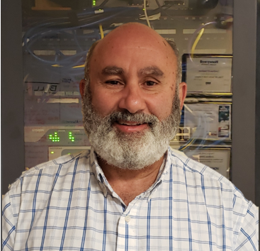
Kevin Chen
Student at Western School of Technology (IT Networking Program)
Intern at Caton Communications Group, Inc

