CCG Technicians Enhance Their Security Skills With The ICT Protege WX Certification

[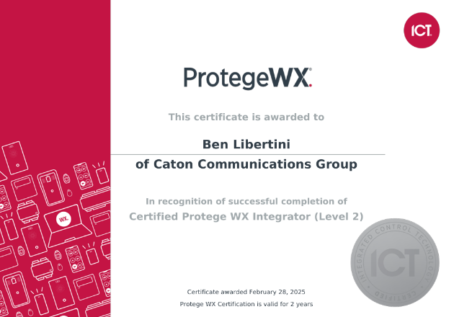](https://ccgusa.net/wp-content/uploads/2025/04/ben-wx-lvl-2-cert.png)

Criminals are always looking for ways to steal from businesses, but thankfully security systems are constantly being improved. The new [Integrated Control Technology (ICT) Protege WX](https://ict.co/products-solutions/our-systems/protege-wx/) provides an innovative yet intuitive approach to access control, and CCG now has technicians certified as Protege WX Integrators.

On February 24th, CCG Technicians Ben Libertini and Josh Jones headed out to Denver, Colorado to take part in an instructor-led [ICT Training for Protege GX and WX](https://ict.co/training-certification/), completing both in the span of a week. Under the guidance of ICT Technical Instructor Jason Semmens, Ben and Josh planned, installed, and configured Protege WX and GX systems for intrusion detection and access control solutions.

[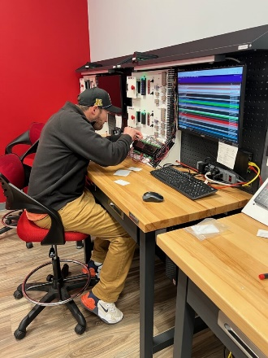](https://ccgusa.net/wp-content/uploads/2025/03/IMG_4302-rotated.jpg)

Ben Libertini configures the [Protege WX DIN Rail Controller](https://ict.co/training-certification/protege-wx-training-kit-and-metal-base-enclosure/).

As part of their training, Ben and Josh were given [Protege WX and GX Training Kits](https://ict.co/training-certification/protege-wx-training-kit-and-metal-base-enclosure/), consisting of a ProtegeWX Controller, Intelligent Power Supply, Touch Sense LCD Keypad, Card Readers, and Proximity Cards. Thanks to their dedicated training, they are now familiar with installing and integrating Protege WX and GX systems.

[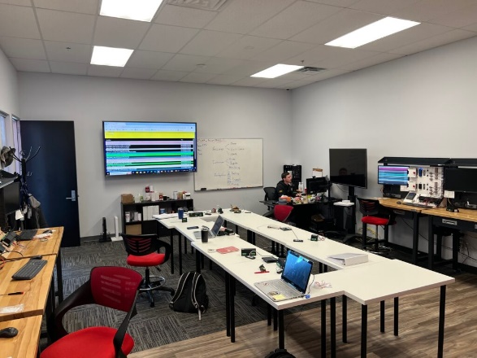](https://ccgusa.net/wp-content/uploads/2025/03/IMG_4301.jpg)

Josh Jones inspects the Events log in the Protege GX Web Client.

Not only did they master installing the hardware for Protege systems, Ben and Josh also familiarized themselves with the Protege GX and WX Web Clients, learning how to program and automate alarm settings as needed. They now know how to customize Protege to suit unique client needs.

[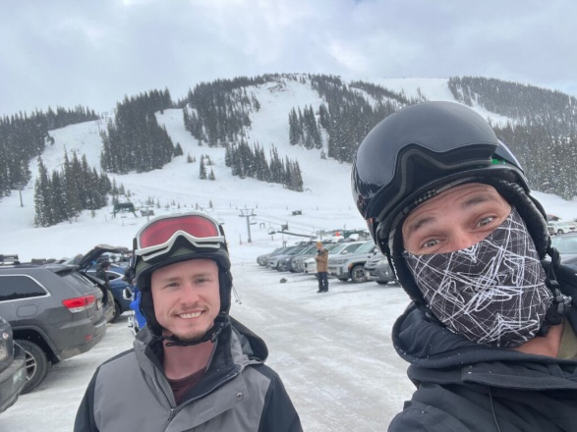](https://ccgusa.net/wp-content/uploads/2025/03/IMG_4293.jpg)

Josh and Ben get ready to ski.

Of course, no trip to Denver is complete without some skiing. Ben and Josh celebrated their successful completion of the Protege GX Installer and WX Integrator certifications by skiing down the snow-peaked Rocky Mountains, ready to take on whatever challenges awaited them, whether in skiing or in access control.

So, if you are looking for a reliable team to install an innovative access control solution, look no further than CCG! Fill out our [quote form](https://ccgusa.net/cabling.html) to get a free estimate on what it may cost you.