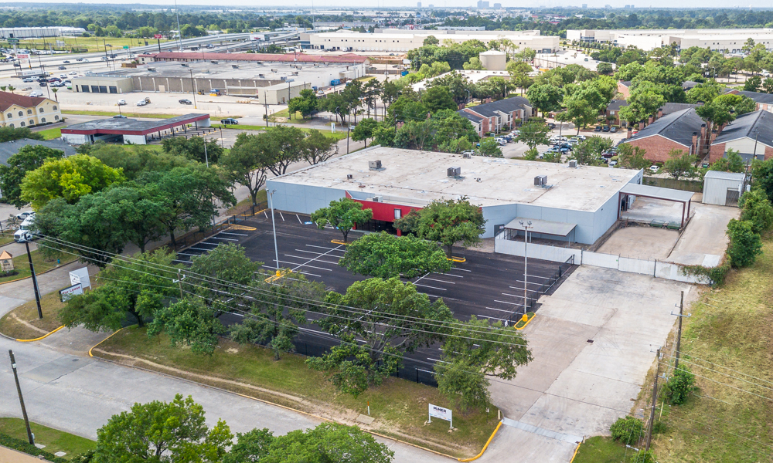
With the increased demand for close-in space, Archway Properties is underway a major renovation and repositioning of the newest addition to its mixed-use portfolio—a distribution/warehouse in North Houston.
Archway Properties will wrap up construction by the end of June at 300 Bammel Westfield Road, a 29,250-square-foot former service center bought as a value-add play. The 2.3-acre property is situated one block from the Interstate 45-FM 1960 intersection, a strategic location for fulfilling a pressing need for last-mile delivery of services and goods.
“Now more than ever, it’s critical for businesses to be located within the last mile of delivery in their trade areas. Customers are shopping and seeking services much closer to their homes than they were three months ago,” said Jason Smith, business development director of Houston-based Archway Advisors, the buyer’s brokerage arm.
Keeton Construction Services of Houston is demising and white-boxing the interior of the single-tenant project, keeping intact 950 square feet of showroom space, and opening up the balance of the structure to create “a nice slate for a user’s future build-out,” Smith said.
Archway Properties has also upgraded the building’s electrical service. The parking lot has been resurfaced, re-striped, and configured for 60 vehicles with a section reserved for outside storage or additional parking if needed. The project features three loading docks, bay doors, and a stand-alone wash bay.
The neighborhood includes retail, restaurant, industrial, and multifamily properties as well as a 423-bed hospital, HCA Houston Healthcare Northwest. Close by are the Grand Parkway/TX 99, Beltway 8, Hardy Toll Road, and I-45. The latest research shows the
region’s industrial market was the best-performing property sector in Q1, with distribution/warehouse space as the absorption leader.

